**4.3**

x(1) is instance 1…

there is a vector w for each

x sub 0 is the bias term

J is the objective function that we want to minimize

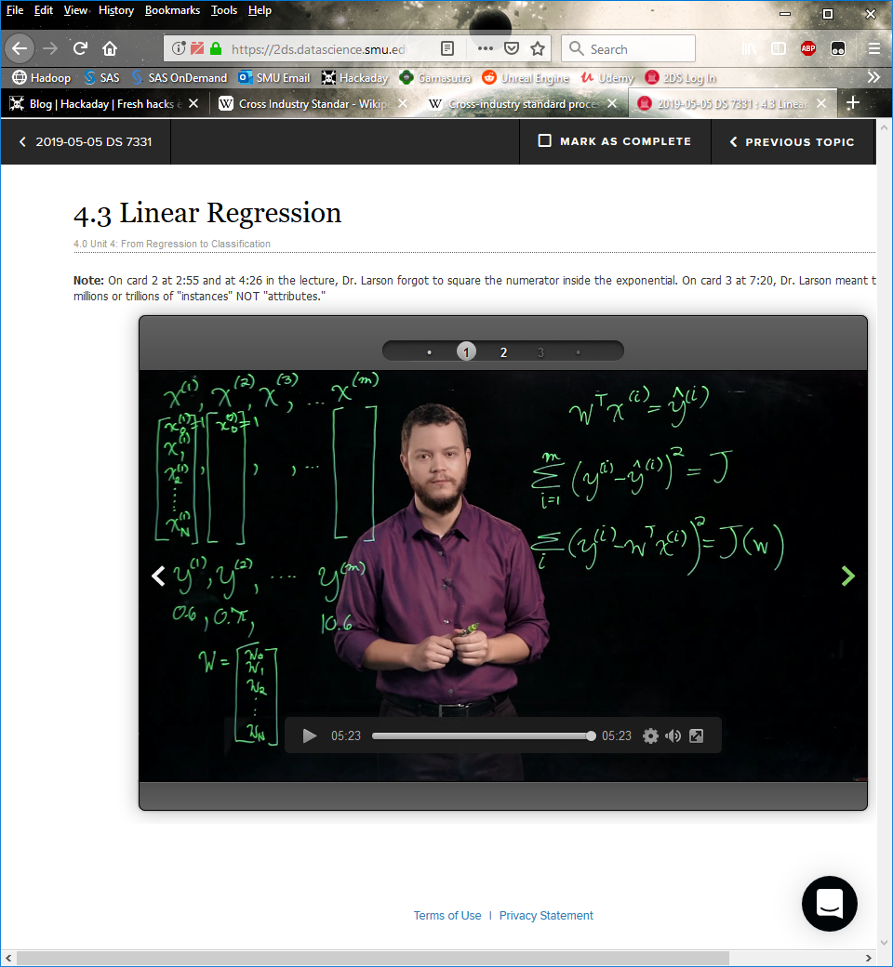 (trying to minimize the sum of squared errors)

Ex is the noise

Ex follows a Gaussian distribution (via the central limit theorem)

N is Gaussian distribution

N(mean, variance)

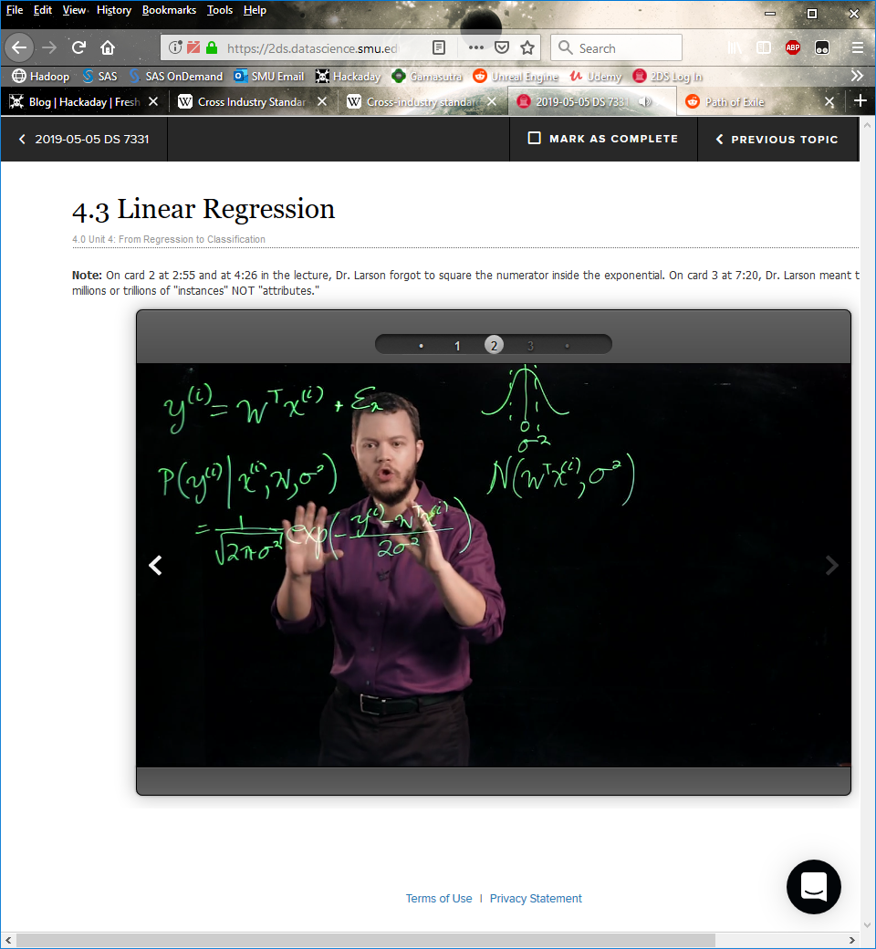

Probability of the ith instance of y [ P(yi|…) ]

Maximum likelihood estimation (w?)

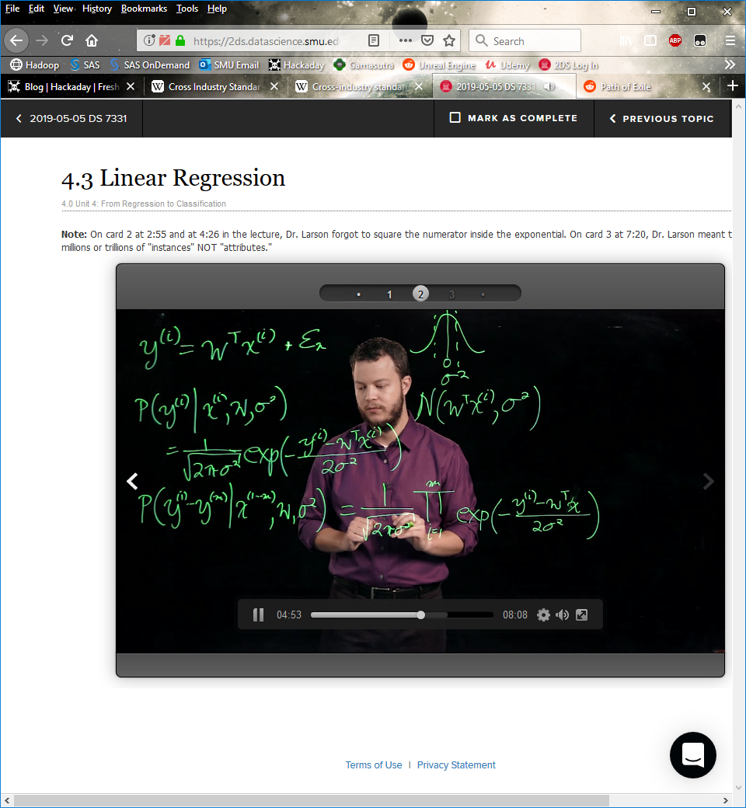

The ln(1/2*pi*sigma…) can’t be changed so doesn’t affect our w

Max of negative == min of positive

To maximize the total likelihood it’s the same as minimizing the equation below

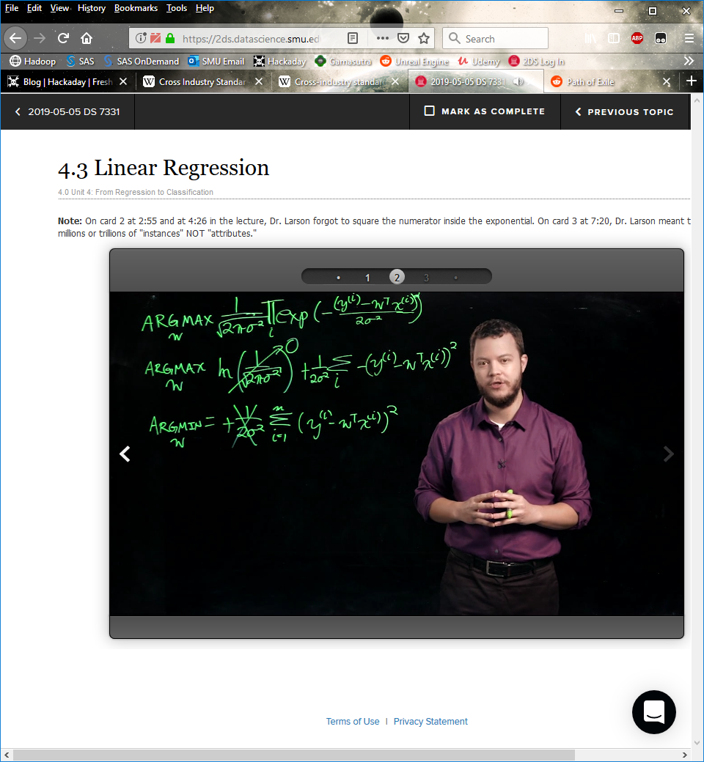

The triangle is the gradient, which is the derivative for a matrix

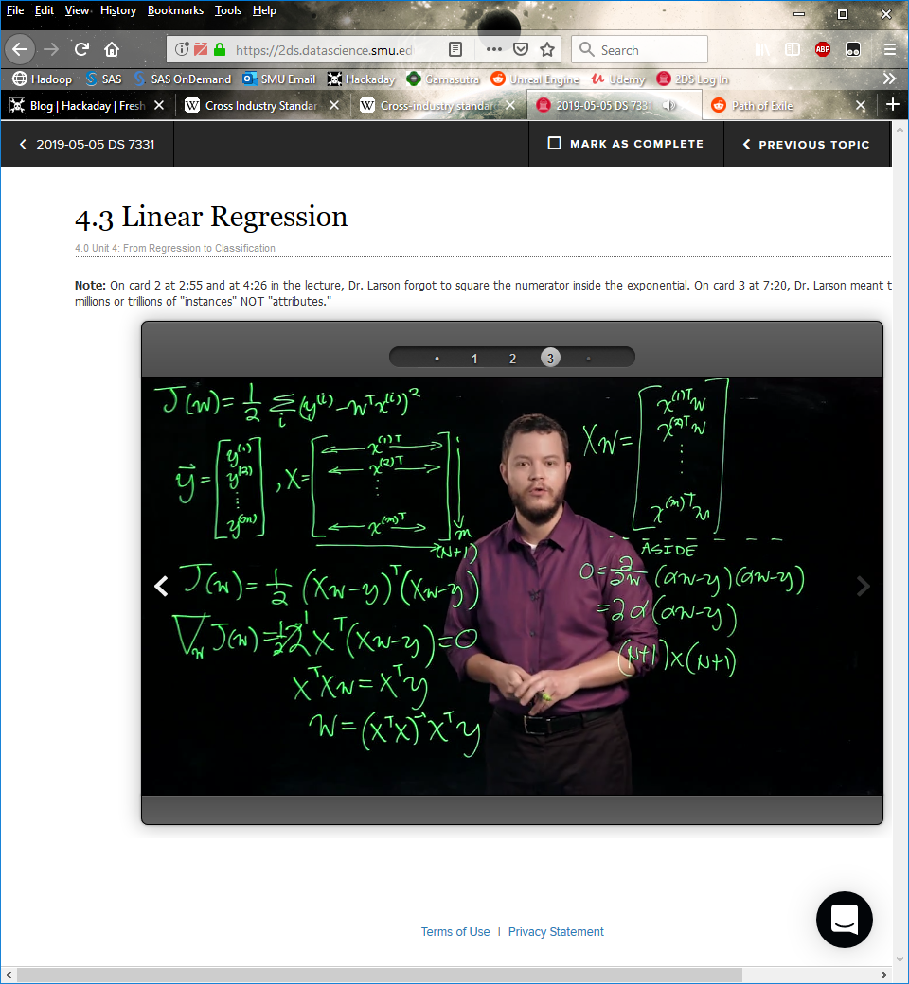

**4.4**

Steepest Descent

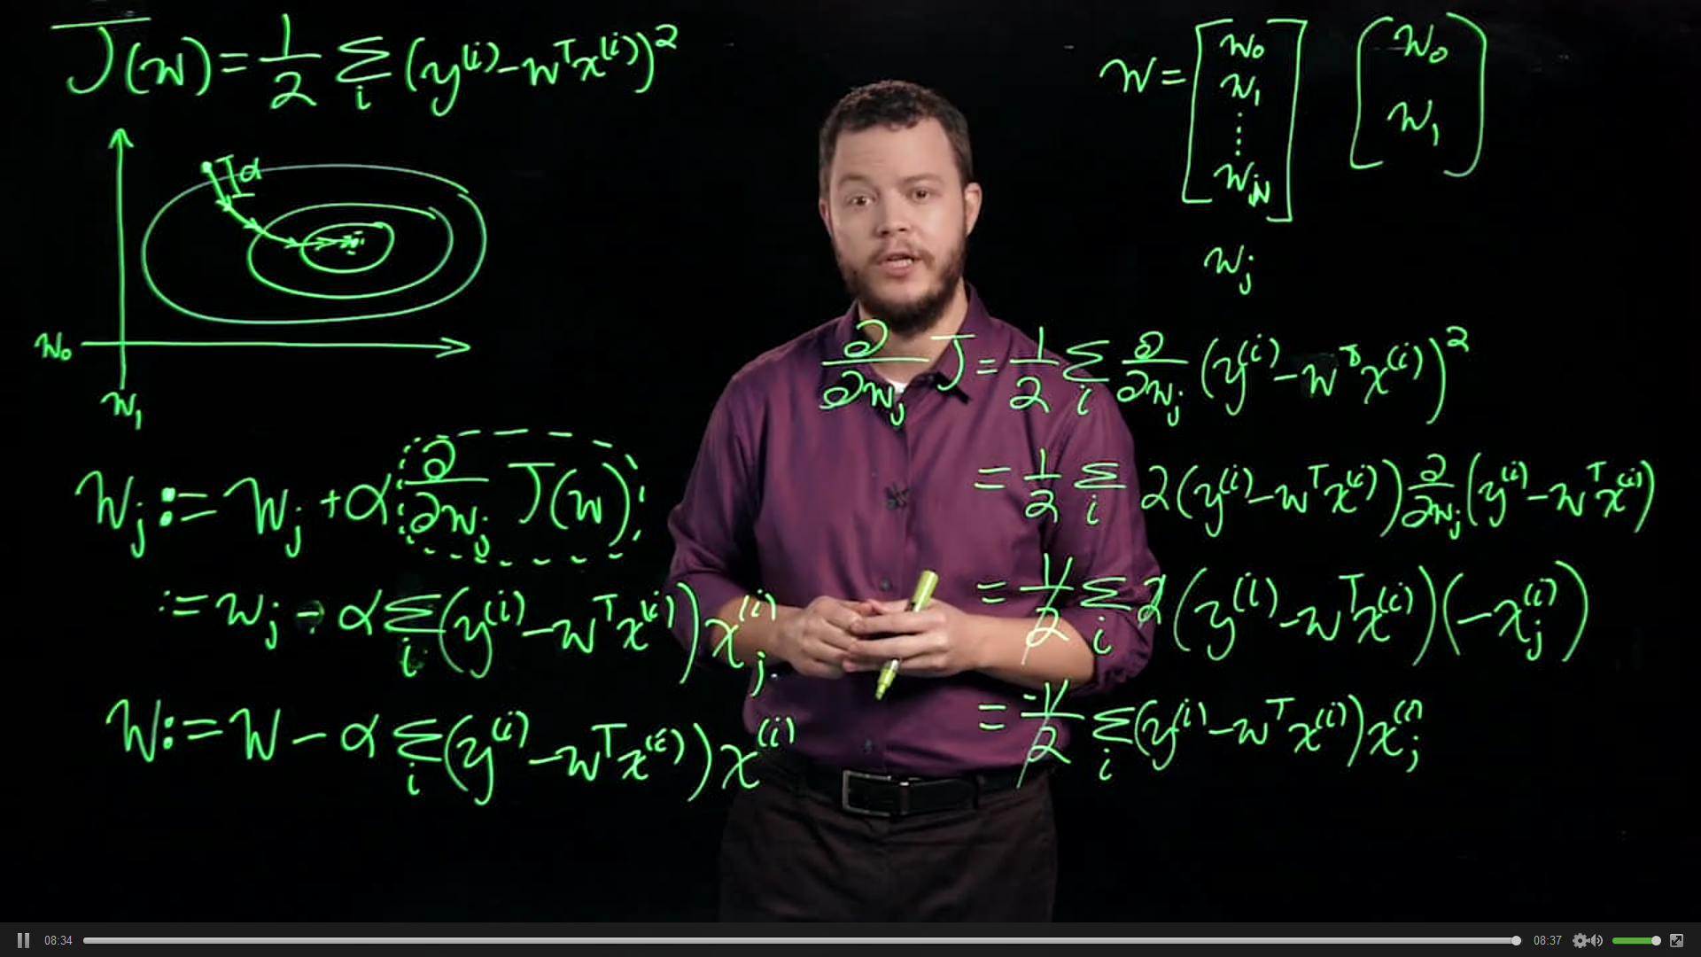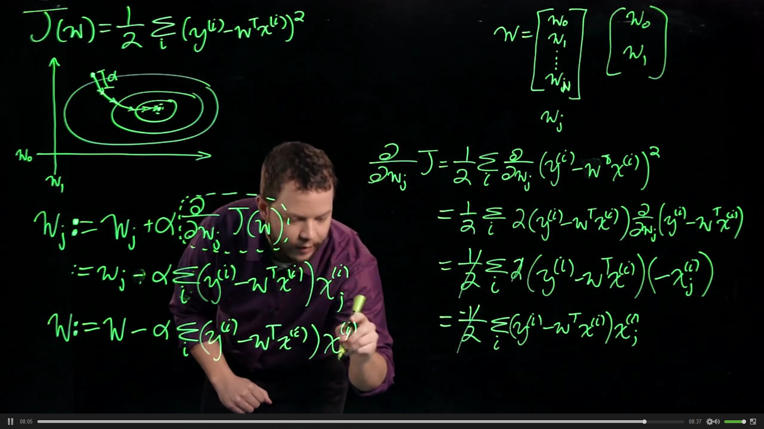

**4.5**

Because derivative of g doesn’t behave properly, we just set it to 1

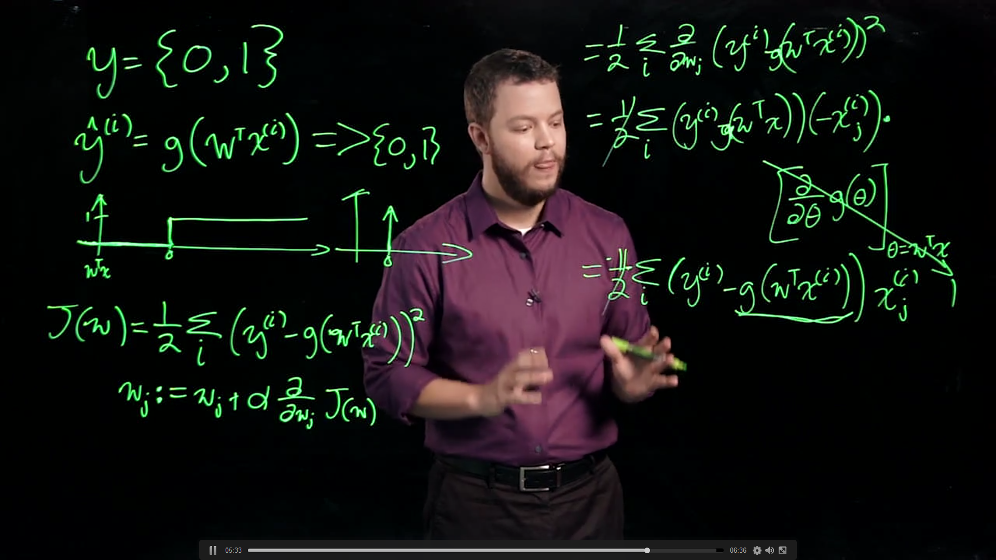

Logistic or sigoid function g(alpha) = 1/(1 + exp…)

Perceptron

Back Propagation

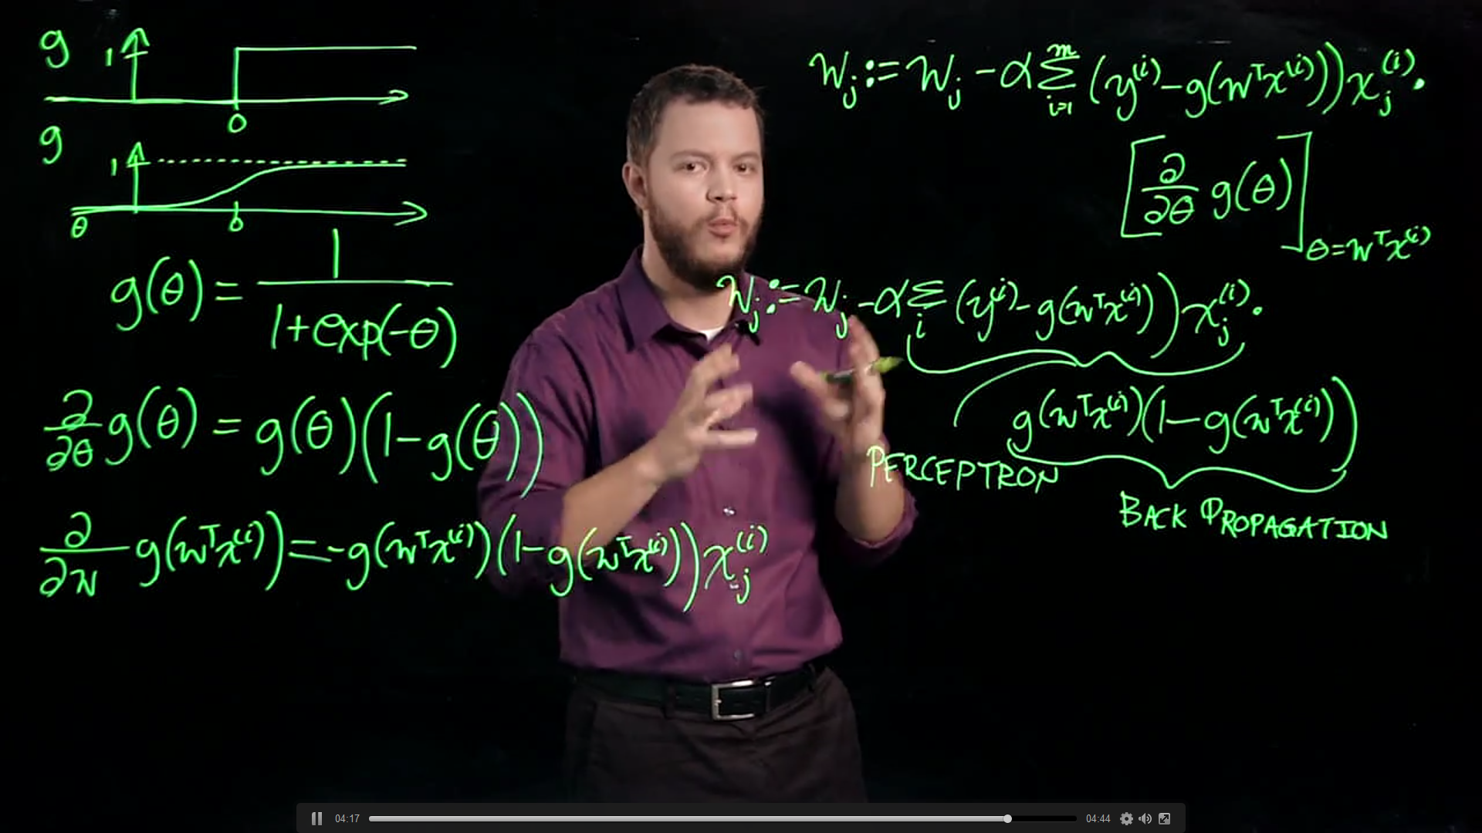

**4.6**

Logistic Regression is not regression, it is a classification problem

L(w) is the likelihood of w

